Introduction

Patient Health Ltd is a small to mid-sized healthcare company that specialises in healthcare and treatment plans for 1000 clients. They operate both physical healthcare centres and are in a major push to improve their online presence through online consultations and tailored advice centred around each of their clients.
The company want a more data-driven approach to how they handle their advice to their clients across their healthcare programs. The objectives they would like to accomplish is to find out how many of their existing clients are likely to leave the company due to a range of features outlined in their dataset. This will allow the company to offer more tailored advice and to create more targeted marketing campaigns for their clients to ensure they retain their customer base and also to attract more clients to the company’s offerings.
The company’s other objective is to look at their customer base as a whole using this data-driven AI/ML approach and for a customer segmentation analysis to be conducted. This will help the company see how their existing client base is grouped and to find out whether there are any existing patterns in the data that will emerge to help them in tailoring their advice to each of these groups.
The report will contain a thorough analysis firstly looking into a customer churn analysis the company is asking for. It will look at a variety of models from a supervised learning standpoint these include Logistic Regression, Random Forest and Gradient Boosting models analysed individually and then compared to eventually conclude on a recommended model that the company can use now and into the future. It will then look at a customer segmentation task and use such models such as K-means clustering and other dimensionality reduction techniques such as PCA and T-SNE to help the company understand its customer base better. They will then be able to tailor more specific promotions and marketing campaigns to better serve their customer base and to also attract other new customers to hopefully increase the company’s revenue and allow them to conduct their business better in a competitive landscape.
The dataset will be drawn from the company’s existing database and this will be used in both analyses ensuring all efforts are taken into the secure use of the data is adhered to in both data transit and storage.
The recommendation will include a deployment platform to use for the company to help monitor the model e.g. Azure Monitor and ensure if data drift did occur, they could be warned ahead of time to perhaps a redesign/retraining to incorporate new data and potentially any new customers that join. This will not only ensure reliability and accuracy of the model but also be able to give them a real-time update to how the model is performing and mitigate any potential latency issues that the model may have and these can then be addressed accordingly.

Problem Analysis

As noted in the introduction of this report the healthcare company are trying to address two clear objectives from this work. The first is to conduct a customer churn analysis that will help the company understand more clearly why, if at all, their existing customer base is intent on leaving. The company will be using an AI/ML solution to address this problem and this report will conduct a detailed analysis outlining a few of the AI/ML models e.g. Logistic Regression to Gradient Boosting that can address this issue with a comparison between all of them to discuss the pros and cons of why there is an optimal model. This will help the company provide more tailored marketing campaigns and promotions that can help target each customer to ensure they are retained and potentially offering recommendations to new customers for the company.

The second problem the company would like to address is understanding their customer base more effectively. They have an existing database but have no way of understanding how their customers are potentially grouped. This will again support their goal in providing more targeted campaigns across their existing customer base and also to offer promotions and discounts to potentially attract new customers to their company using the customer segmentation analyse. This AI/ML solution provided in this report as noted using such models as K-means clustering will offer the company a more unique insight into their customer base and help solve this objective.

PatientHealth Ltd dataset is drawn from the company’s own database and includes their total existing 1000 customers with 13 individual features, these features include:
Customer ID, Age, Gender, Tenure Years, Visits Per Year, Satisfaction Score, Has Chronic Condition, Premium Amount, BMI, Number of Claims Last Year, Average Claim Amount, Exercise Hours Per Week, Churn
The data is a mixture of numerical e.g. Visits Per Year and categorical data e.g. Gender and the categorical data will need to be addressed with methods like one-hot encoding to ensure an effective dataset for the models to use.
An example of this is below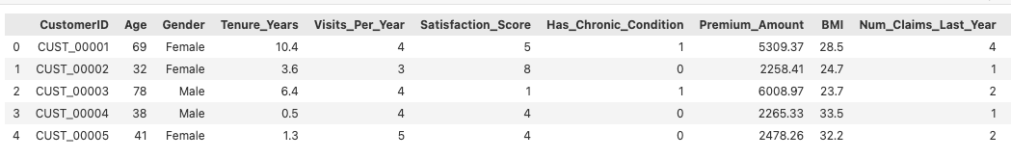

What is needed to be addressed is the potential class imbalance in the dataset, where for example the data set is heavily weighted (75%) with a class majority of non-churn customers over churn customers (25%) this will need to be addressed to mitigate potential bias and inaccurate predictions the models do make through the use of fine-tuning the parameters of each of the models such as class weight set to balanced in the Logistic Regression model to ensure both training and testing sets of data are balanced.
A number of models will be considered in this report and will outline both the benefits and issues with all of them to ensure that scalability does not become an issue when the company through its targeted marketing campaigns eventually attracts new customers to their healthcare programmes. The data input will need to be cleaned effectively to identify any possible outliers, missing values or unreliable rows of data that might have to be removed or through the use of a Z-score to ensure data is within a certain threshold. For this report outliers will be assessed at the 3 standard deviations threshold. If there are any missing values then mean imputation will be used to ensure a data point can be averaged and the customer can be included.
Also, because the dataset has many features included the equal contribution of all features used is needed so where needed the data will be scaled to ensure this contribution is effective. The StandardScaler method from SciKit learn will be used to ensure accurate scaling.

The security of a dataset like this especially as it’s a healthcare company needs proper handling of the data to mitigate any possible security concerns whilst the data is being used this will be outlined further on in the report but it is important to highlight this challenge here.

Technique Selection

Logistic Regression was the first model to be used for the customer churn task for its ease of implementation to the problem with a very simple design to use once the dataset had been properly pre-processed and cleaned. What needs looking at is the design of the dataset here i.e. does the dataset incorporate class imbalance, in this case it does. 75% of the target variable, churn, is weighted to not churning this then provides the model potentially with an inaccurate view of the healthcare company’s clients and leads to high precision and accuracy scores because the model has learned that the majority of the features explain a customer from leaving. However, this is not true as 25% of the dataset has customers that are likely to leave so this can be mitigated through parameter tuning such as class_weight and setting this to ‘balanced’ and making sure the model has enough epochs to ensure it has had a good look at the now balanced training data leading to better evaluation metrics. It is also very good at classifying unseen records once trained properly leading to good efficiency and accuracy of its predictions on the unseen data. However, as the dataset may scale i.e. leading to more customers joining through the target marketing campaigns this model tends to lend itself to overfitting where the model learns the training sets patterns and then fails poorly on the test set. This is not good when scalability is a priority for the company and regularisation techniques such as L1 and L2 can be used to avoid this scenario.
Due to this dataset included only a small number of features in comparison to the number of customers logistic regression would be fine to use in this case however, as the healthcare company brought on more customers and added new features to the dataset logistic regression begins to struggle to find patterns in the increasing complexity of the dataset itself and may provide false predictions when deciding whether a customer may leave or not, which would lead to potential revenue loss for the company and cost increasing due to poorly targeted marketing campaigns.

Random Forest was the second model considered for the churn task and is a great model to handle complexity because it uses a model architecture that includes multiple decision trees and then merges them together by voting, in classifications tasks, leading to a more optimal prediction. A visualisation of this structure is below.
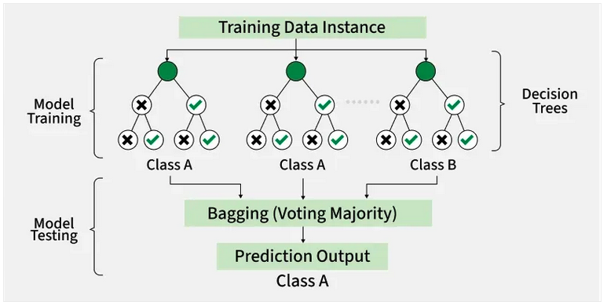
It handles large datasets well and would be able to handle the increasing complexity of the healthcare dataset given it is only 1000 customers and 13 features at this stage, ensuring future scalability when those new customers and features are added.
In the context of the customer churn problem, it would perform well in this prediction task and be able to handle the number of features in this dataset and provide accurate predictions once trained on the dataset.
It is also adept to handle the overfitting issue i.e. where the model fits too closely to the training set and then can’t make any great predictions on its test set leading to poor accuracy and precision evaluation metrics.
An example of overfitting is provided below
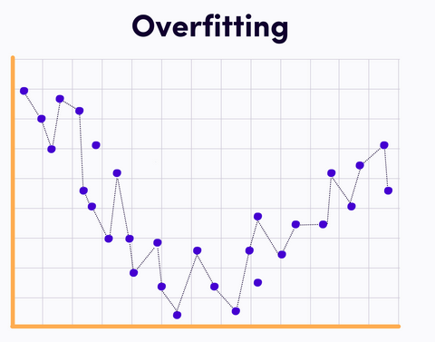
Due to this complexity though the model can become less interpretable and for potentially a non-technical future user this would be increasingly problematic. Leading to misunderstandings in its output and potentially poorly tailored advice and marketing campaigns based off of this, leading to increasing costs and potential losses in revenue for the healthcare company. However, this will hopefully be mitigated through successful hyperparameter tuning.
The last model considered for the churn problem was Gradient Boosting, this builds models sequentially meaning the next model learns from the previous failings of the previous model.

An example of its architecture is below:
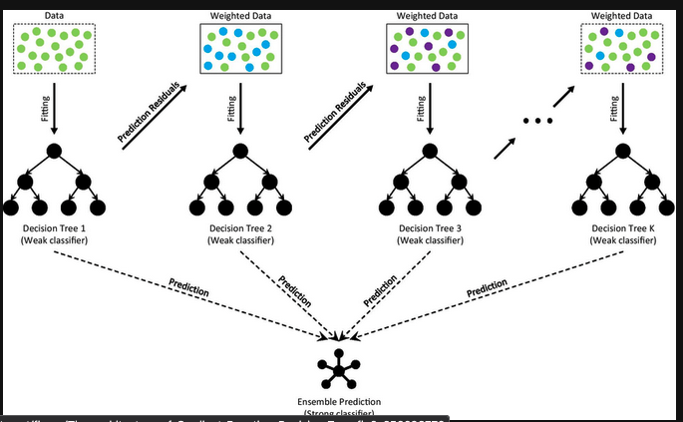
Correcting for the mistakes or poor predictions of the previous model and iterate and create a new model through continual new testing and tweaking and improving on the past models. This makes it ideal for the customer churn problem with a good dataset it should be able to improve upon its overall predictions to unseen data and provide accurate and precise results leading to good evaluation metrics.
It has very high predictive accuracy as articulated and is very well suited to small and medium sized structured datasets which is perfect for the type of dataset that the healthcare company has at this stage.
It does fall down when datasets become larger and can take up time training itself however, this dataset is still in its infancy with only 1000 customers and 13 features so far and it is not going to drastically change in the near future. And to mitigate these issues it does have the parameter max_features which limits the number of features that any one tree can have, limiting the complexity and also the parameter n_estimators which is basically how many trees can be used in the overall model also helping with the complexity issue and compute time that this model sometimes has.

It can also be tuned using Grid Search to find the optimal hyper parameter to use to fully utilise its predictive power and this will be explained later on in the report.

For the customer segmentation problem, K-means clustering, T-SNE and PCA are all unsupervised techniques to be used in helping the healthcare company understand their customer base better.
K-means clustering is a natural selection for this type of customer segmentation task. It pulls related datapoints together into a set number of clusters to show the user how the dataset is potentially set into multiple different groups based off the dataset’s features.
However, K-means has a dimensionality issue where if the dimensions of the dataset increase the effectiveness in the K-means output can fall, a way to mitigate this issue is by using a dimensionality reduction technique such as PCA (Principal Component Analysis), this helps reduce a dataset to its most basic components whilst holding onto as much information as possible about the dataset.
This will address the potential future scalability issue that K-means will be associated with and ensure that the dataset continues to provide the K-means model with an effective dataset to analyse.
T-SNE will be used here to help simplify this dataset and ensure the healthcare company has a clear visualisation of the data, it works well when data has high dimensionality and can include a lot of noise in the dataset. If will also be used in case the analysis from both the K-means and PCA analysis graphs do not clearly define any concise segments of customers.
PCA is also another dimensionality reduction technique to be used alongside T-SNE because as the dataset scales T-SNE can become computationally expensive leading to higher costs for the company where as PCA can be used instead and possibly maybe part of a future retrain of the model as the dataset includes more customers.

Implementation details

The dataset included 1000 customers with 13 features and came with a variety of both numerical and categorical data types. To ensure the model could handle the data effectively a few data cleaning techniques were employed to handle this issue.
These included handling the categorical columns of the dataset (Gender, Region and Smoking Status) that needed to be transformed into a numerical data type. The technique employed here was one-hot encoding and it targeted this issue. The algorithm used was SciKit Learn’s OneHotEncoder using the parameters sparse_output, handle_unknown, to ensure the data was handled successfully.
An example of the syntax is included below,
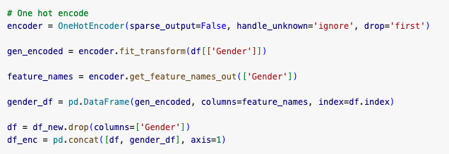

The method used was fit_transform that targeted these three columns and the get_feature_names_out method was also used to ensure that the names of these columns were carried forward into the new Pandas DataFrame.
The old columns that had the categorical data type were removed using the drop method and finally the new encoded columns along with the rest of the existing DataFrame was concatenated using pandas concat method.
Then to ensure the data was setup for the logistic regression’s input and target variables i.e. with Churn as the target variable, the columns of the new DataFrame had to be reordered using the reindex method the syntax is below.

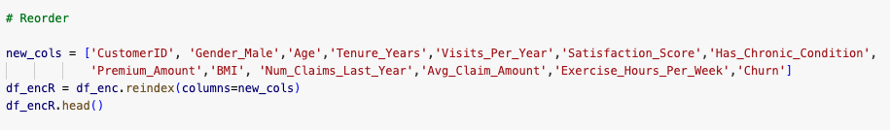
A Z-score was conducted to find any outliers in the dataset that were more than 3 standard deviations away, this reduced the dataset from the initial 1000 customers to 934 customers. This ensured the variance of the data was reduced and to ensure the data was reliable and ensured results from the model were consistent and accurate.

For the gradient boosting model, GridSearch was used to ensure a number of parameters were tested to help optimise the Gradient Boosting Classifier. GridSearch allows the user to test a list of different parameters and output the best parameter values it believes will optimise the model the best.
The code for this is below,

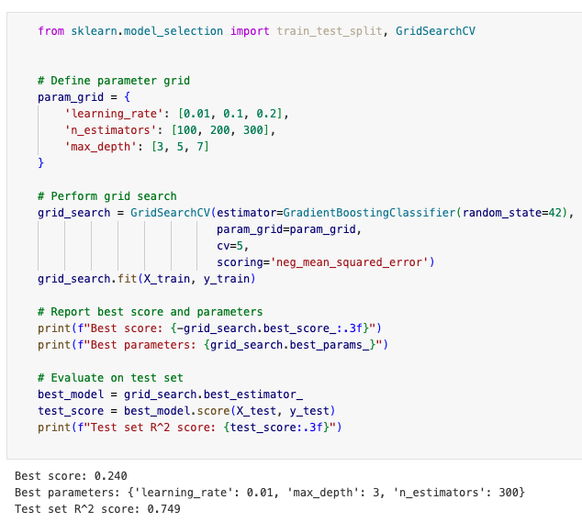

Feature Engineering
For the customer segmentation analysis, the clustering algorithm K-means was employed where the columns that were not needed i.e. that would cause the greatest amount of variance in the analysis such as columns with the one-hot encoding were dropped from the dataset. This included the columns of Gender and Smoking Status
There were also new features added to the dataset for the customer segmentation exercise to ensure it was more business centric. Using Pandas assign method, new features included:
Spending_Intensity = Premium Amount / Tenure Years
This new feature was to help figure out how much the client was spending with the business over the years they were with them. The company of course wants this to be as high as possible to ensure revenue generation from each of their customers is as optimal as possible.
Claim_Frequency = Number of claims last year / Tenure Years
This new feature tells the company how much the customer is costing the company from the time they have been with them and of course this needs to be as low as possible.
Engagement_Score = Visits Per Year + Exercise Hours Per Week
This new feature is to find out how often the customer is attending the healthcare company and their engagement with their healthcare plan. This feature ensures the company understands how effective their advice is being to the customer themselves.
An example of the syntax for this is below: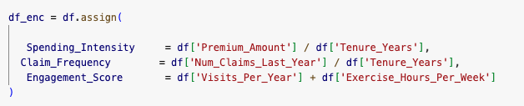

To ensure the models generalise well the cross-validation training and testing split will be 80/20. The method train_test_split was used on the pre-processed data (one-hot encoded, scaling etc). It is to note here the parameter stratify was used to address the challenge above of class imbalance. It ensures that the proportion of different classes in the dataset is maintained in both the training and test sets. This helps address the imbalance in the dataset and helps give a more representative sample for the model’s training and evaluation.
Also to mention the test_size parameter was set at 0.20 ensuring the explained test set was 20% of the overall dataset and the model had a good majority of 80% to train itself on.
Also, the random_state parameter of 42 was used in this case to ensure the model could be held in a particular state to ensure reproducibility of these test conditions when used at other times.
The syntax for this is below:

For T-SNE the perplexity number chosen here was 50 ensure and good balance between local and global data structures where local focuses on the relationships between individual data points and global focuses on the overall structure and the variance of the entire dataset, a high number was chosen here to ensure scalability for when the model is handling a larger dataset. Here we also look at fixing the model’s state to ensure reproducibility. An example of the model is below.

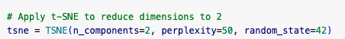

As noted, a variety of models were used in the development process these included Logistic Regression, Gradient Boosting and K-Means Clustering to name a few.
Below is a discussion on how these models were developed and the reasons why some were discarded.

The customer segmentation task was to give the company a better idea of their customer base. It used another database that included the same 1000 customers but with 13 different features using all continuous data for model accuracy and efficiency.
The techniques employed here were Principal Component Analysis that was to aid in reducing the dimensionality of the data to help simplify the dataset before feeding it to the K-means clustering model. There was also the addition of a t-SNE (T-distributed Stochastic Neighbour Embedding) conducted to help with visualisation of the dataset. And where necessary helped show the cluster structure data better than PCA so is included in this report for clarity.
To ensure a good set of features used for this data the forward feature selection technique was used to find the best features which helps with reducing overfitting and make the results more easily interpretable.
An example of the feature selection syntax is shown below,
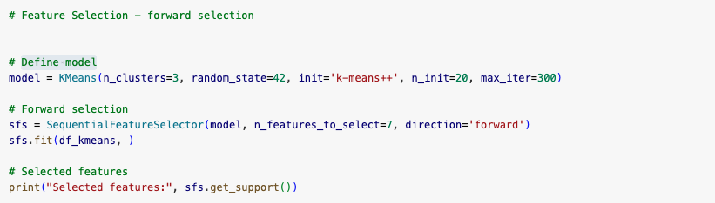
However, because this is a computationally expensive method and doesn’t handle well with large datasets and potentially future new features this will be discarded in the final model architecture presented to the company to ensure scalability and efficiency with an expanding dataset of new customers in the future.
The data was then scaled using SciKit Learn’s Standard Scaler method to ensure an equal contribution from all features of the dataset. And one-hot encoding was not employed here because no columns were of a categorical nature. An example of the syntax for this is below:

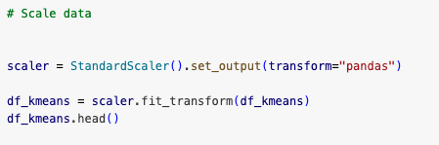

The Elbow method was used to find the correct number of clusters to use. This involves plotting the within-cluster sum of squares (WCSS) against the number of clusters and where the line graph almost pivots at shows the optimal number of clusters.

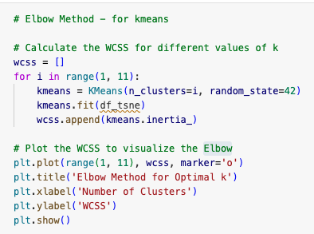

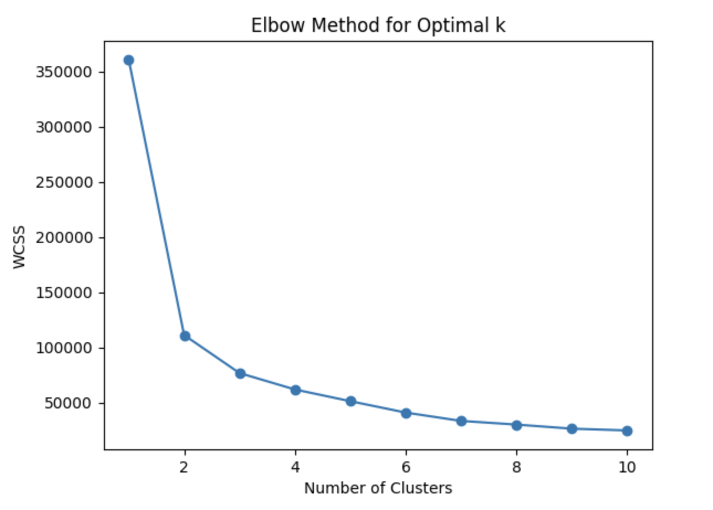
From the graph above here we can see the optimal clusters sat between 2 and 3 clusters and three clusters was chosen for the parameter of the model. The random state of 42 was chosen to ensure model reproducibility in the future and to ensure that any future user would have the same testing conditions to use that helps with conducting future testing and predictions.
The K-means model was built using the following parameters in mind. The method of initialisation used was k-means++ because it is good at speeding up convergence of the model and will be a useful initialisation parameter to use going forward as the model is scaled using more data. It is when the model has reached a point where the performance stabilises and that any further training will not significantly reduce the loss or improve accuracy. So, this is an important parameter for both scalability, efficiency and accuracy long term as the health care company scales the number of customers.
The number of times the k-means algorithm would run was set at 20 to ensure good optimisation over the data and it allows the model to produce the best of the 20 runs it has in its settings especially as the dataset may scale it is important that the healthcare company have highly accurate representations of their customer base and this setting ensures that.

Customer Churn

For the customer churn task, a number of models were considered that included Logistic Regression, Random Forest and Gradient Boosting.

The data was first evaluated using a Z-score to remove any outliers within 3 standard deviations to ensure a smoother dataset for the model to use, this was carried forward into both the Random Forest and Gradient Boosting models.
Also regularisation was tried in this case L2 regularisation because the solver LBFGS in SciKit Learn’s Logistic Regression model does not allow L1 penalisation and so LASSO was not employed here. However, having conducted multiple tests with different values it made no difference to the overall results and so was not included as part of the overall model’s construction.

Logistic Regression

The first model considered was Logistic Regression an outline of the model’s syntax is below:

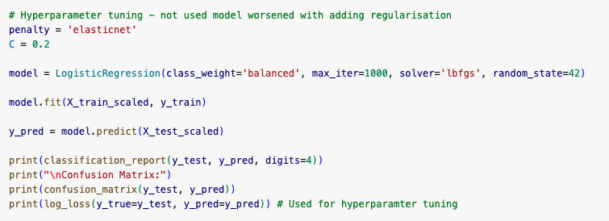

SciKit Learn’s Logistic Regression model was trained with the following training parameters in mind. The class_weight parameter this was set to ‘balanced’, why because this dataset has a majority class of 0 (75%) in the non-churn category meaning the dataset is heavily imbalanced and the model would perform well but this would be inaccurate because it is easy for the model to predict churn = 0. It is trained on these “stay” patterns and would then not be good at determining features that would class a customer as a “leaver” (churn = 1) when shown unseen data, it is a false high accuracy. You would then achieve very low false positives leading to unnecessary retention offers costing the company where it didn’t need to spend its budget, and you would also have very high false negatives leading to loss of customers and thus revenue impact. So, the parameter class_weight helps mitigate these issues by ensuring the model is shown a more balanced view of the dataset and hopefully more accurate scores on the evaluation metrics (Precision, Recall, F1-Score).
The solver model used was L-BFGS it was used in this case because it is efficient in handling large scale datasets ensuring the model’s future scalability as the customer base will potentially grow as the tailored marketing campaigns are created.
Maximum iteration was set at a 1000 to ensure a good number of epochs that would hopefully produce a good amount of training for the model and ensure good overall accuracy for the model to then be used on the unseen data.
Random state was used here to ensure randomisation conditions were kept the same for future reproducibility where needed.
The model was then fitted with the cleaned, pre-processed and scaled data (using StandardScaler) alongside the target variable, in this case churn, training set. Using the .fit method.

Random Forest

The next model used for this dataset was Random Forest, used for its greater predictive power and better at combating overfitting if there were to be any in the data.
Here a number of different parameters were tested including most importantly class_weight that had the value ‘balance_subsample’ this helped with the class imbalance issue highlighted before and was included here. Random State was used to ensure accurate reproducibility of the model and to ensure as the dataset scaled the model was still performing at a consistent level.
The forest was limited to a max depth of 10 as the dataset was small it did not need to have an overly complicated model.
An example of the Random Forest model being implemented at the testing stage is provided below:
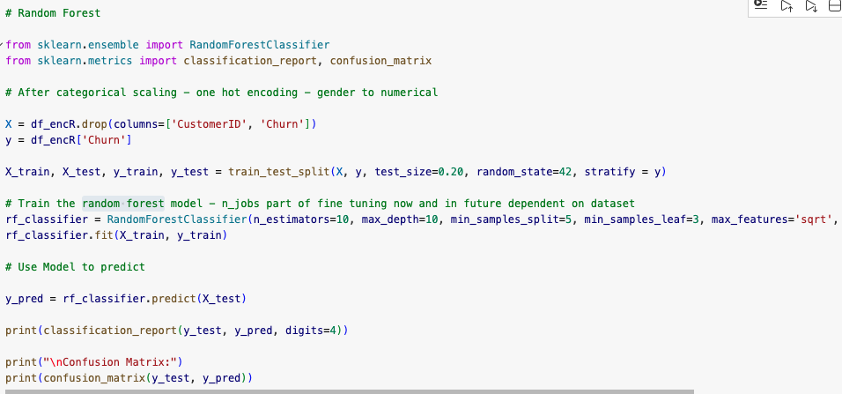

The N_jobs parameter was indeed considered to be included here as it helps to optimise computing hardware to maximise the performance of the model. Good for a growing dataset and scalability along with efficiency. This parameter might be part of the retrain process in the future as the dataset scales and there is more demand on the random forest model this could be fine-tuned to fit the newly sized dataset. However, was not used in the final model as the performance was negligible given the size of the dataset.

Gradient Boosting

The last model considered for the churn problem was Gradient Boosting, this builds models sequentially meaning the next model learns from the previous failings of the previous model.

It has very high predictive accuracy as articulated and is very well suited to small and medium sized structured datasets which is perfect for the type of dataset that the healthcare company has at this stage.
It does fall down when datasets become larger and can take up time training itself however, this dataset is still in its infancy with only 1000 customers and 13 features so far and it is not going to drastically change in the near future. And to mitigate these issues it does have the parameter max_features which limits the number of features that any one tree can have, limiting the complexity and also the parameter n_estimators which is basically how many trees can be used in the overall model also helping with the complexity issue and compute time that this model sometimes has.

A list of the tools and libraries used are as follows:
- Programming Languages: Python
- Libraries and frameworks:
  - Libraries: NumPy, Pandas
  - Supervised learning: SciKit-Learn, Gradient Boosting, Logistic Regression,
  - Unsupervised learning: Scikit-Learn, K-means clustering, Principal Component Analysis, t-distributed Stochastic Neighbour Embedding
- Cloud platforms: Microsoft Azure (for deployment), Azure Machine Learning for model training and monitoring
- Data Visualisation: Matplotlib (Bar, Scatter), Seaborn (Regplot)

Evaluation and Results
The results for the K-means clustering is below alongside the graph of K-Means using a scatter plot from matplotlib with the syntax and graph below.
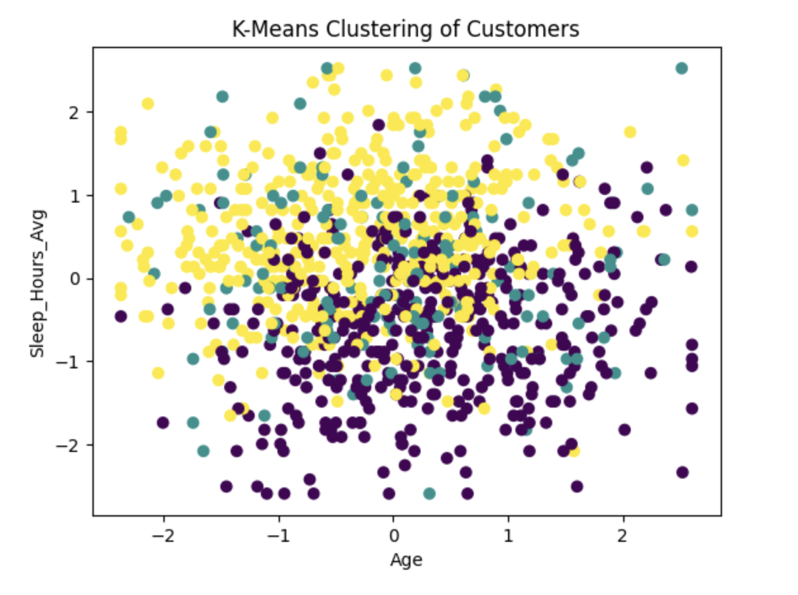
There is a lot of overlap in this data showing the relationship between Age and Sleep_Hours_Avg here. K-means clustering computes the average distance between each datapoint dependent on where the initial central centroid is situated however, multiple datapoints can sometimes belong to multiple clusters simultaneously and that is what is being shown here, it also does not show the complete segmentation of customers because this is only a two-feature case.
What is needed here is to employ dimensionality reduction to map the higher dimensional data onto a lower dimensional plane and that is why both Principal Component Analysis and T-SNE were employed to help clear up the visualisation of the data. PCA reduces the number of dimensions of the data whilst explaining as much of the variance of the dataset in each of the principal components employed, in this case the parameter was set to two components.

The result also did not produce any values of -1 which would signal that the dataset still had outliers, so this was a good sign as it ensured the Z-score analysis had mitigated any possible outliers from the initial dataset. Therefore, no adjustment to the parameters such as min_samples and eps were needed.

The graph for the PCA output is below:
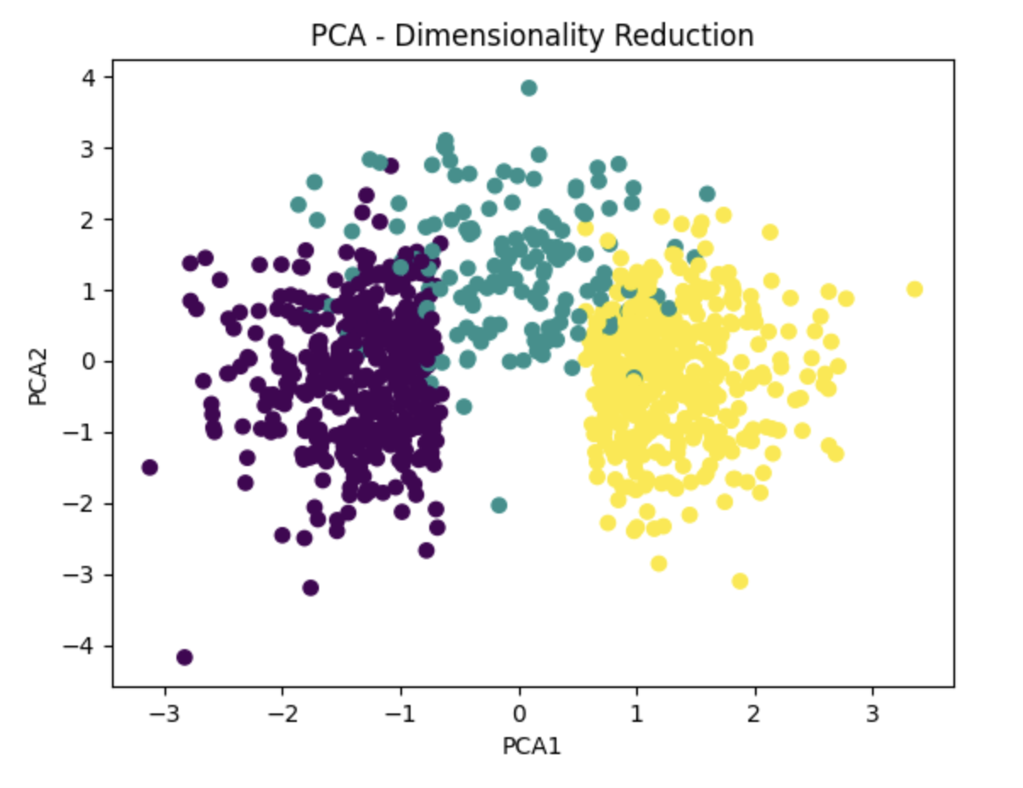
This shows the clusters much more effectively than purely the K-means output and although there is some overlapping here there is clearly three distinct segments of customer that the company can visualise and use to help tailor and improve on their marketing campaigns.
To check how well PCA did in capturing the variance in the data the variance was extracted from each of the components alongside a cumulative sum of the explained variance to show this. The syntax and outcome are provided below:
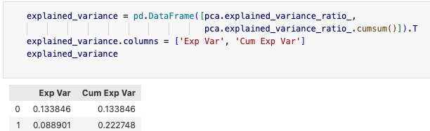

From this analysis there is only 22% of the cumulated variance captured by the PCA however, this is not unusual for healthcare related data and it simply means that there is no single or dominant direction that captures most of the variation. The data is proved to be highly dimensional here and somewhat noisy and this explains why there is the overlap on the graph above. It is also an excellent reason why T-SNE needs to be employed here to capture the other relationships in the data and showcase the clusters more clearly.

T-SNE is a non-linear technique that showcases relationships within the data at higher dimensions and might not be acutely apparent in the K-means cluster analysis and PCA. The output of the t-SNE graph is below along with an example of the syntax used to produce the graph.

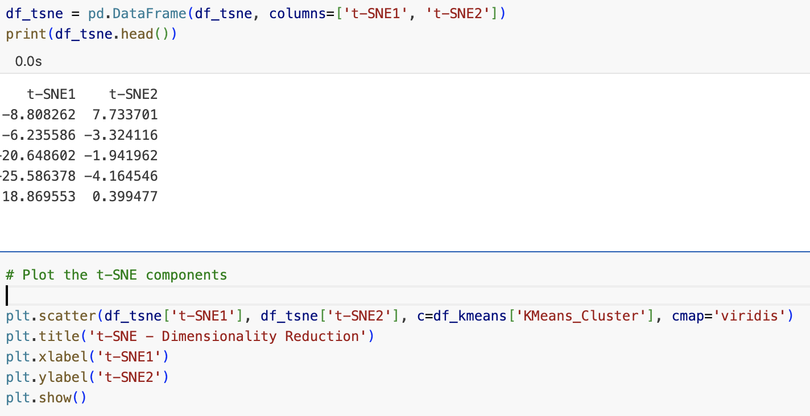
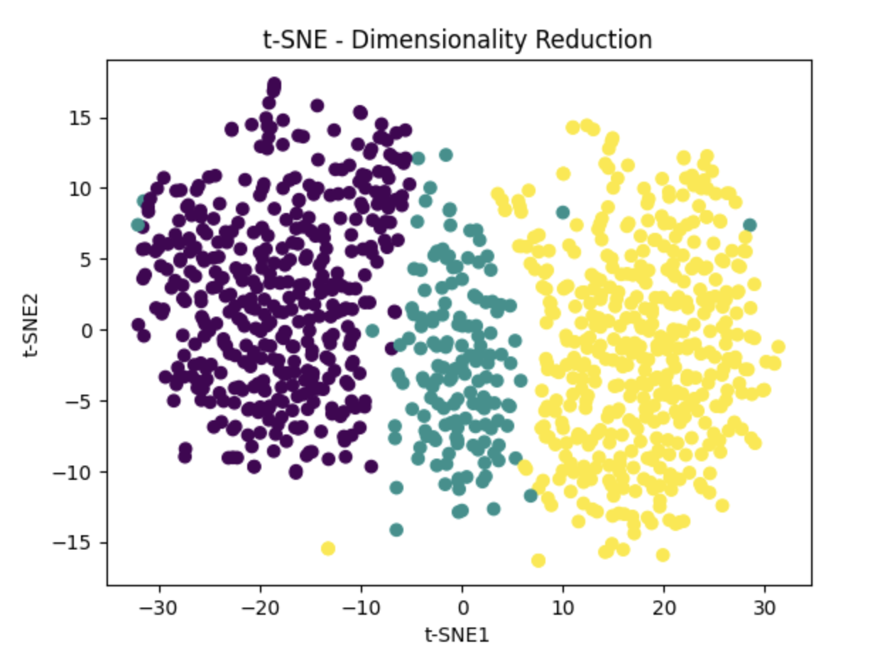
This graph further illustrates the importance of employing multiple dimensionality reduction techniques that highlight the three distinct clusters that was not apparent in especially in the K-means graph. These clusters were also confirmed by the output from the Elbow method employed above also. You can clearly see that the local structures of the data were preserved.

Logistic Regression

Below is the classification report and confusion matrix for the Logistic Regression model
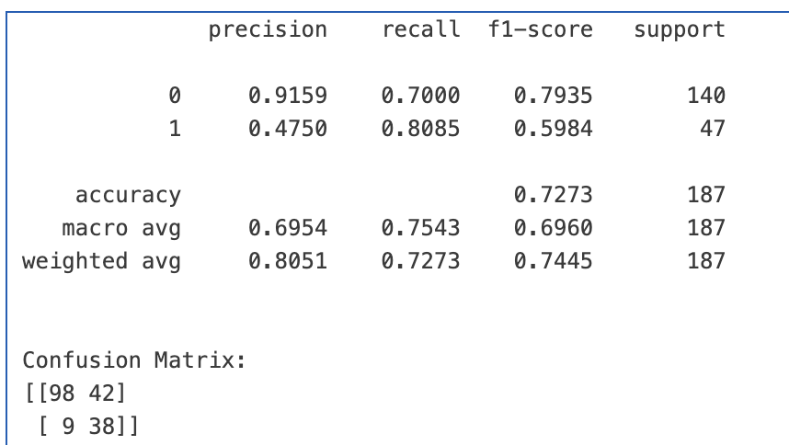

The model performed well across most of the metrics with consistent results of predicting the majority of true positives i.e. how well did the model do in predicting a customer would actually churn. There were consistent scores across the macro and weighted averages, these both measure the level of prediction in the model to predicting the test set value across both classes (churn and non-churn) where you are looking between 60% and 80% which the model achieved.
The defining test the F1-Score that is a better evaluation metric compared to precision and recall because it focuses solely on the positive class (i.e. Churn =1). This is especially relevant because of the class imbalance in the dataset and therefore a better evaluation metric to focus on in this case.
However, there were mixed results when it came to the confusing matrix scoring the lowest True Positives out of all the three models tested here and also scoring the highest False Negative meaning it missed customers that were intending to leave but the model predicted would stay, this is one of the major reasons why other models were considered.
Computing the ROC curve allows a reliable metric to understand how well the model does predicting overall. This is shown below,
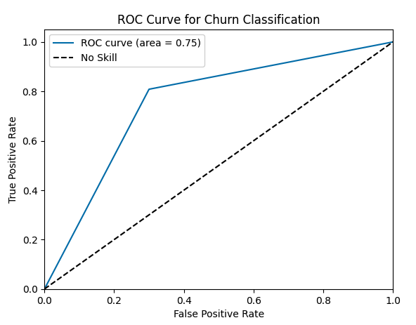
The model in 75% of cases predicted accurately whether a customer was intending to leave of course this could be higher but after conducting hyperparameter tuning including the use of L2 regularisation and looking to minimise the cross-entropy loss, this was the best the Logistic Regression could do.
When running the Gini importance for the Logistic Regression graph it clearly identified the three most important features of the dataset were Satisfaction Score, Premium Amount and Tenure Years, the graph of which is below. This shows the company that when designing their marketing campaigns and promotions for both existing customers and new customers it will be important for them to consider these and shows if they are not addressed customers will consider leaving.
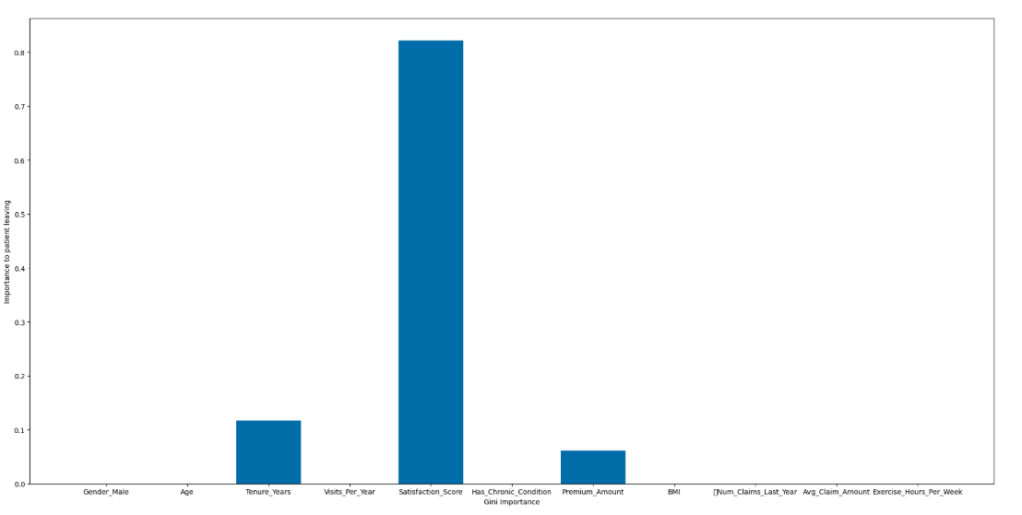

Random Forest

Below is the output from the evaluation metrics for the Random Forest where it did well with decent F1-Scores of 83% and 46% (i.e. predicting correctly those that would not churn and those that would respectively) this could be slightly skewed due to the imbalance in the dataset despite trying to mitigate this using the class_weight parameter value of ‘balanced_subsample’. In the confusion matrix, the model did do ok with a high number of true positives however, there were a number of false negatives here i.e. showing the model did predict that the customer was intending to stay when in fact they were looking to leave.
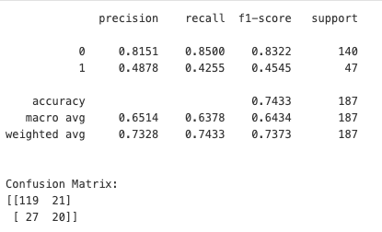

What it did do well in was when a Gini importance graph, run using Matplotlib showing all the features contributing to the churn of the customers finding that the satisfaction score was most prominent but not dominant with a lot of the other features being captured by the model. Including the customers premium amount having the second most important factor in contributing to whether they would churn or not.
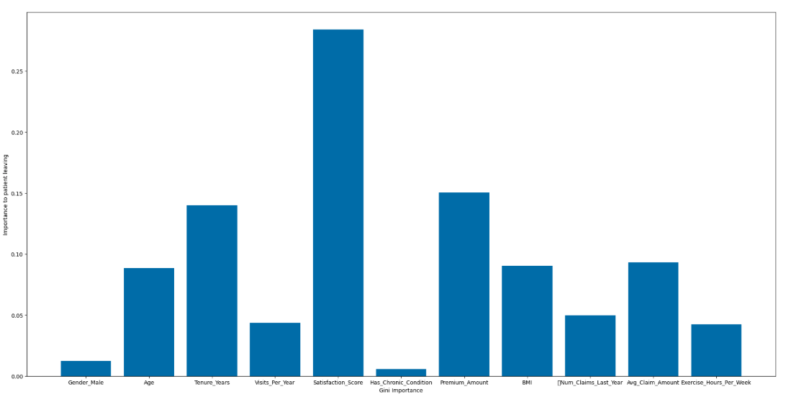

Gradient Boosting

The final model to be tested is the Gradient Boosting algorithm, the classification report is below.

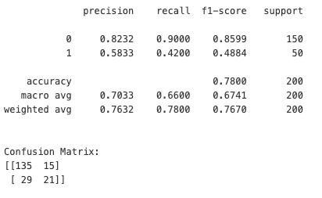

This produced again acceptable evaluation metrics scores although in this particular case the f1-score was slightly lower than the logistic regression’s prediction and only in 49% of cases did the model predict that the customer would leave the company. However, scored highly with an 86% of the time predicting a customer would stay.

In the confusion matrix, you can see out of the 200 customers given to the model in the test set it correctly identified 135 true positives meaning it correctly predicted a patient who will leave did in fact end up leaving. This was the highest score out of all three of the models chosen and is one of the reasons why it will be recommended to be taken forward by the company.

It scored well across both its macro and weighted averages ensuring consistent performance when looking at both the churn and non-churn classes.

When looking at the Gini Importance graph for this model, we can see that the satisfaction score was the most prominent feature showing that customer satisfaction across all the services offered by the model is key, this showed up in the Random Forest and Gradient Boosting. With again Tenure Years and Premium Amount being prominent features in the decision to stay which would be consistent with a healthcare company’s dataset showing the model’s performance is high here.

The graph for this is below,
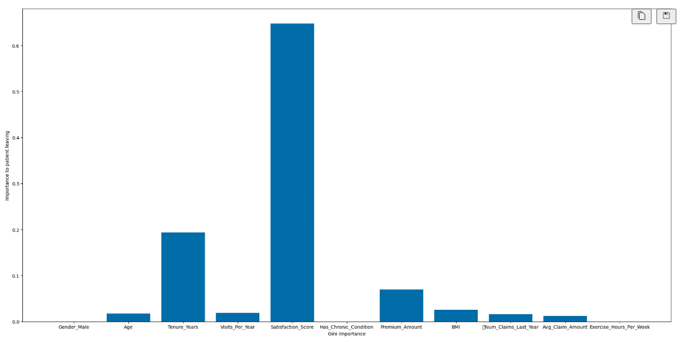
Comparison between the models

All models predicted well when comparing their Gini Importance graphs that Satisfaction Score, how long they had been with the company and premium amount was by far the most important features to consider when factoring in how their customers think about them as a company. This was prominent across all three models and needs to be highlighted as a recommendation for the company to take forward when thinking about whether their customers will churn or not.

The accuracy in the models did differ when comparing their confusion matrices with the Logistic Regression performing the worst with only 98 out of the 200 customers being picked correctly i.e. True Positives and the Gradient Boosting model performing the best with the highest True Positives of 135 out of the 200 being correct predictions of churning when testing it on the unseen data.

Conclusion

This report set out to identify two tasks a healthcare company wanted to provide to help it understand its customer base more effectively.

Firstly, customer segmentation task was carried out using three different techniques K-means, PCA and T-SNE to identify whether there were any unique segments of customer that good be identified and targeted with more tailored marketing campaigns and promotions. Three distinct groups were clearly identified from the analysis that the company can use along with their own individual features to help themselves formulate more effective marketing and promotion to not only target their existing customer base but also it can now be used as a tool for new customers.

Secondly, customer churn, the company wanted to identify what, if any, the reasons customers were thinking of leaving the company. Having run three different models Logistic Regression, Random Forest and Gradient Boosting, all three clearly highlighted the top three reasons were Satisfaction Score, how high their premiums were and how long they had been at the company. Despite the shortcomings of Logistic Regression, it still identified satisfaction score as the top reason for why a customer was going to leave.

The model going forward for this to be recommended to the company for analysing customer churn will be Gradient Boosting where they will be able to grow their existing customer base and the model will be able to provide them with consistent and accurate predictions of whether a customer is intending to leave or not. For the customer segmentation task, it will be as stated in the analysis a combination of using PCA and/or T-SNE to reduce the dimensionality of the data alongside K-means clustering.

In the future, with potentially new features being added and more customers coming to the company retraining of the models maybe needed. The deployment platform Azure will be recommended especially for its design to ensure data is secured at rest and in transit through AES 256 encryption to protect the healthcare company’s data especially given the sensitivity of the data it has. Azure’s Machine Learning Service for ease of integration into the company’s existing systems alongside, Azure Kubernetes Service to ensure that if the dataset does grow rapidly the modelscan be scaled to meet the new demands and finally Azure Monitor to ensure continual monitoring of the models in operation and ensure if there are any breakdowns or latency issues in the models this will be highlighted early so any potential retraining e.g. the n_jobs parameter in the Gradient Boosting models to ensure if needed the correct computer hardware is used optimally to ensure continual smooth compute of the model’s output, that maybe needed or fine-tuning can be done without disruption to the company’s operations.

The models could in the future be used on a variety of different datasets that the company may want to compile perhaps using different features than the ones in this dataset and perhaps would benefit from adjustment in the parameters once these had been tested to ensure the models was still maintaining accurate predictions for churning and that there marketing campaigns were up to date and still successful when targeting the company’s segmented groups.

Sources

- https://colab.research.google.com/github/lewtun/hepml/blob/master/notebooks/lesson03_random-forest-from-scratch.ipynb

- https://www.researchgate.net/figure/The-architecture-of-Gradient-Boosting-Decision-Tree_fig2_356698772

- https://www.researchgate.net/figure/The-architecture-of-Gradient-Boosting-Decision-Tree_fig2_356698772

- https://www.geeksforgeeks.org/machine-learning/random-forest-algorithm-in-machine-learning/

- https://levity.ai/resources

